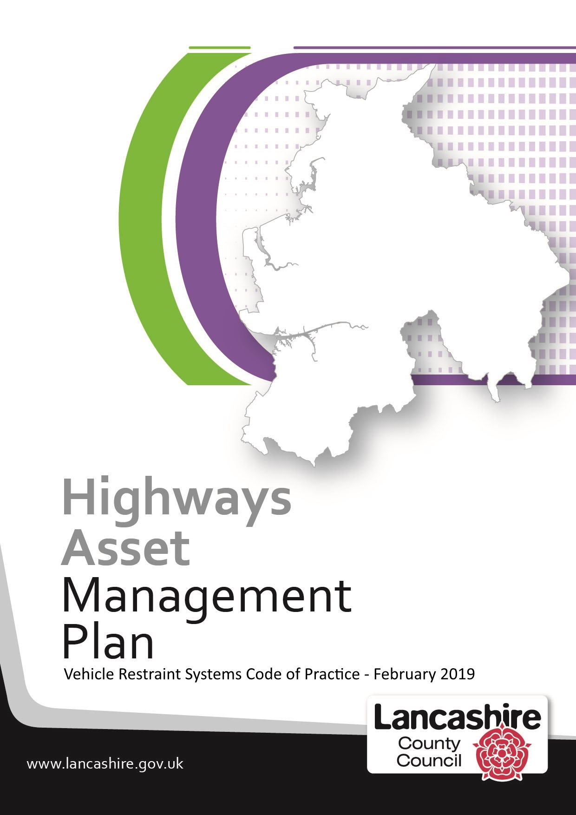

Contents

Section | Description | Page No
1 | Introduction | 3
2 | Assessment of need for the provision of vehicle restraint systems | 5
3 | Inspection and maintenance regime | 6
4 | Record-Keeping | 8
Appendix A | Summary of key guidance | 9
Appendix B | Vehicle restraint system appraisals | 11
Appendix C | Design and installation of vehicle restraint systems | 13

Date of next review - December 2022

1 - Introduction

Background

Vehicle restraint systems are intended to reduce the number and severity of injuries in the event that a vehicle leaves the carriageway and would otherwise encounter a hazardous feature (e.g. on-coming vehicles, an embankment, a lighting column, trees, etc.).

Vehicle restraint systems, which are also referred to as road restraint systems in this code of practice, do not stop accidents from occurring and they should only be used when other measures are considered inappropriate or ineffective.

Lancashire County Council currently maintains approximately 130 km of vehicle restraint systems comprising of high containment concrete barriers, steel/wire fences, tensioned/un-tensioned safety fences or bridge/structure parapets. They are distributed across a wide range of locations on our highway network with varying road speeds and traffic flows.

Scope of this Document

This code of practice promotes the use of a risk based approach to the installation of new vehicle restraint systems, as well as the management and maintenance of existing VRS to ensure a consistent and optimum performance across Lancashire.

The implementation of this code of practice will ensure that:

- new vehicle restraint systems are only installed after all other measures have been considered
- new vehicle restraint systems are installed to the appropriate standard
- vehicle restraint systems are recorded on the Highway Asset Management System
- maintenance of vehicle restraint systems will be prioritised following a risk based approach
- where we propose a departure from national standards or guidance this decision is fully risk assessed and signed off by appropriate personnel

As national guidance on vehicle restraint systems is not collated in one place and is complex, this document is intended to be a reference document to support design and highway maintenance engineers when considering vehicle restraint systems and to set the risk based method by which the council prioritises detailed inspection and minor maintenance; in order to optimise the funds whilst reducing the risk.

Guidance and Departure from National Standards

This code of practice has been developed with reference to:

- TD19/06 Requirement for Road Restraint Systems (TD19/06)
- Design & Maintenance Guidance for Local Authority Roads Provision of Road Restraint Systems on Local Authority Roads (DMG-RRS)
- Well Managed Highway Infrastructure: A Code of Practice (WMHCoP)
- TAL 06/03 Managing accidental rail obstructions by road vehicles (TAL 06/03)
- IAN 97/07 Assessment and Upgrading of Existing Vehicle Parapets (IAN 97/07)
- British Standards documents - BSEN1317 and BS7669-3
- Highways Act 1980

We will use the above guidance wherever it is applicable and practicable to do so. The contents and scope for each of the vehicle restraint systems guidance notes listed above is included at Appendix A

Where we propose a departure from national standards or guidance, this decision will only be taken after carrying out the appropriate road safety audit and/or risk assessment and will be signed off in accordance with the Lancashire County Council Design and Construction 'General Procedure GP008 Departure from Design Standards' Form (GP008). Further information about record keeping is provided in Section 4 – Record Keeping.

2 - Assessment of Need for the Provision of Vehicle Restraint Systems

It is expected that all practical attempts should be made to prevent new hazards being created or to design them out, thus avoiding the need to consider vehicle restraint system provision. Where this is not possible this guidance is applicable.

Different guidance is available, depending on the location, speed limit, traffic flow and type of hazard, for the risk appraisal process of a vehicle restraint system site. Table 1 at Appendix B provides a guide to selecting the most appropriate risk appraisal guidance and associated risk assessment based on these criteria.

The relevant guidance gives examples of the circumstances and hazard types which justify the need to undertake the appraisal process to determine the need to provide a vehicle restraint system are provided in both TD19/06 and DMG-RRS. Such examples include roadside obstructions such as structures, trees and lighting columns, hazards that road users may fall off or into such as embankments and water sources and hazards where others may be affected such as recreational areas and railways or flammable material storage

In order to give a consistency of approach for the interpretation of the results of the chosen risk assessment, Table 2 at Appendix B converts the results of the different risk assessment methods into the risk / priority bands of 'higher', 'medium' and 'lower'.

The risk assessment process is only part of the appraisal process and, regardless of the risk assessment band achieved by a vehicle restraint system site, consideration should be given to suitable, cost-effective and practicable alternative options which will reduce the level of risk to a level which will avoid the need to install / continue to provide a vehicle restraint system. DMG-RRS provides examples of alternative solutions for consideration of sites on local roads. Such solutions include the removal or relocation of hazard, speed control or the installation of chevrons and signs etc.

TD19/06 requires that road safety audits must be undertaken on all highway schemes involving removal, provision or improvement of vehicle restraint system.

Comprehensive records of the processes followed and the decisions made should be kept and stored in line with the relevant guidance and the requirements outlined in Section 4 – Record Keeping.

Where, as a result of the above procedure, a decision is made to install vehicle restraint system, Appendix C provides guidance on the design and installation of vehicle restraint system.

3 - Inspection and Maintenance Regime

Highway Safety Inspections (HSI)

All our vehicle restraint system installations are subject to a regular basic visual inspection as part of the Highway Safety Inspection policy which prescribes the frequency of inspection, the method of assessment, recording and repairing of highway defects. Only those defects which are obvious, clearly visible and pose a threat to safety are picked up, recorded and actioned by this process.

General / Principal Bridge Inspections

A large proportion of our vehicle restraint systems installations are associated with structures. In accordance with the Well Managed Highway Code of Practice, vehicle restraint systems will be inspected as part of the highway asset, as well as part of general and principal inspections for structures, where it is practical to do so.

Risk-based Inspection and Minor Maintenance Programmes

We will develop risk-based inspection and minor maintenance programmes primarily using the existing highway maintenance hierarchy to categorise sites into one of the following priority bands:

Priority Band | Network Hierarchy
Higher Priority Sites | Strategic Route / Main Distributor
Medium Priority Sites | Secondary Distributor / Link Road
Lower Priority Sites | Local Access Road

Having prioritised road types into bands, further prioritisation within the bands will take place using the nature of the hazard being protected. Highest priority will be given to vehicle restraint system sites with hazards where third parties could be affected e.g. a vehicle crossing a central reserve into on-coming traffic.

Having selected an appropriate route to inspect, we may for efficiency purposes, inspect all vehicle restraint systems on that route, which may include lower priority vehicle restraint system installations, as this will avoid the contractor having to make multiple trips to inspect isolated installations.

As part of the risk-based inspection and minor maintenance programme the contractor will be required to carry out minor repairs such as replacing and/or tightening bolts, etc. Where defects cannot be repaired as part of the initial inspection, the contractor will be asked to report such defects to the Highway Asset Manager so that appropriate action can be taken. This may lead to a vehicle restraint system installation being assessed and included in a future years Capital Programme or works being undertaken using the Department for Transports Incentive Fund.

If insufficient funds are available to address vehicle restraint system defects action will be taken to make such sites safe by a carrying out a range of actions which may include complete removal of the vehicle restraint system, temporarily reducing road speeds, signing and coning, imposing lane closures or closing roads.

Should the risk-based inspection and minor maintenance programme highlight a major issue with our vehicle restraint system assets, action will be incorporate these within the Transport Asset Management Plan when it is next revised.

Upgrade or Repair of VRS

TD 19/06 provides guidance on when consideration should be given to upgrading existing vehicle restraint systems which does not meet current standards and exceptions to this. TD 19/06 also provides guidance on when like for like repairs are permitted on VRS which does not meet current standards. We will follow this guidance, particularly in the case of our 'Higher Priority Sites', wherever it is practicable to do so.

Where practicable every effort will be made to recover all costs incurred in repairing sections of accident damaged fencing or barrier in line with countywide services procedures. This will include the costs of traffic management, making safe, administration and repair.

In accordance with the with National Highways Quality Management Sector Scheme 2B and 5B only suitability qualified personnel should be employed to install, upgrade or repair vehicle restraint systems on our road network Prior to starting works, contractors will be required to confirm that the personnel who will be engaged on such are suitably qualified.

Comprehensive records of the processes followed and the decisions made should be kept and stored in line with the relevant guidance and the requirements outlined in Section 4 – Record Keeping.

4 - Record Keeping

In addition to complying with all the appropriate guidance in this respect, the designer must also enter all the required information into the Highway Asset Management System, or make it available to the relevant team for entry.

The Highway Asset Management System was introduced in 2017 and is still being developed in respect of certain assets, including vehicle restraint systems; a limited number of fields are currently available for use, but they will be expanded over time, as required.

Where the information contained in any of the available fields is affected by actions arising from any of the processes described in this guidance, the Highway Asset Management System should be updated accordingly. All other information/documents relating to the assessment, design, installation, inspection and repair processes should be attached as documents to the relevant record.

Appendix A: Summary of Key Guidance

TD 19/06 Requirement for Road Restraint Systems (DMRB 2.2.8)

This document was published by the Highway Agency (HA) in August 2006. It gives guidance for the provision, design and layout of VRS and was developed using accident data for routes with over 5000 Annual Average Daily Traffic (AADT) and a speed limit of 50mph or greater. It is not a statutory or regulatory document and the mandatory sections are relevant only to Trunk Roads

The 'Road Restraint Risk Assessment Process (RRRAP)' which forms part of TD19/06 is an Excel spreadsheet that enables the designer to determine at each specific site, the need for a vehicle restraint systems and its performance requirements. It also enables identified risks to be categorised as ‘broadly acceptable’, ‘tolerable’, or ‘unacceptable’ and enables the impact of mitigation measures on risk to be assessed and recorded. Guidance on the use of the RRRAP associated with TD19/06 is available online.

Design & Maintenance Guidance for Local Authority Roads Provision of Road Restraint Systems on Local Authority Roads (DMG-RRS)

This United Kingdom Roads Liaison Group (UKRLG) Guidance Document is intended for use by highway authorities and their designers considering the introduction or replacement of vehicle restraint systems on roads with low traffic flows and/or low traffic speeds. It describes a process to assist highway authority decision making with regards to investing in a vehicle restraint systems at a particular site. It includes the necessary supporting information to assist this process and takes account of risk, risk assessment methods, costs, benefits as well as further advice on performance specification and outline design. It is applicable to:

- New roads (and the adoption of roads)
- Road improvements e.g. widening, junction improvements
- Where a new hazard is introduced or an existing roadside feature is altered e.g. the addition of roadside features
- Where the upgrade or replacement of a parapet is being considered.
- Maintenance schemes where a significant length of vehicle restraint systems is being replaced
- When the safety performance of a particular site has been questioned and risk reduction options are being assessed.

TAL 06/03 Managing Accidental Rail Obstructions by Road Vehicles (TAL 06/03)

In line with this guidance all roads that cross or run alongside railways need to be risk assessed to consider how the risk of a vehicle leaving the vehicular highway can be reduced. The scoring system in the guidance provides a methodology to compare the relative risk and highlights any potential high risk areas and a record of risk assessment is made using a consistent scoring sheet for each site and road type. The spreadsheet then provides a record of the audit results.

Appendix B – VRS Risk Appraisal

Different guidance is available for the risk appraisal process of a vehicle restraint system site. The most appropriate methodology is determined by a number of factors including type of road, traffic speed, traffic flows and location.

The table below provides a guide to the scheme designer for the selection of the most appropriate risk appraisal process guidance and risk assessment type, based on this criteria.

Table 1 | Traffic Speed Limit
AADT | <40 mph | 40 mph | >=50 mph
<5000 | VRS generally not required.  (In exceptional circumstances apply  DMG-RRS with  Method A, B* or C) | DMG-RRS with  Method A, B* or C | DMG-RRS with  Method A, B* or C
>=5000 |  |  | TD19/06 with RRRAP
All sites near railway lines – regardless of traffic speed / AADT:
TAL 06/03 - 'Managing Accidental Obstruction Railway Approaches'

(* Method B of DMG-RRS is based on the risk estimation tool which forms part of TAL 06/03)

Key to Abbreviations
AADT | Annual Average Daily Traffic
DMG-RRS | Design & Maintenance Guidance for Local Authority Roads Provision of Road Restraint Systems on Local Authority Roads
TAL 06/03 | Managing Accidental Obstruction Railway Approaches
TD19/06 | Requirement for Road Restraint Systems

In order to give a consistency of approach for the interpretation of the results of the chosen risk assessment, the table below converts the results of the different risk assessment methods into the risk / priority bands of 'higher', 'medium' and 'lower'.

Table 2 | Risk Assessment Method
Risk / Priority Band | DMG-RRS - Method A | TAL 06/03 or DMG-RRS - Method B | DMG-RRS - Method C | TD19/06 -RRRAP
Higher | Above the KSI return period in Table 3.1 in DMG-RRS* | Score of >=100 | Score of  14 or more | 'Unacceptable'
Medium |  | Score of  >=70 | Score of  9-13 | 'Tolerable'
Lower | Below the KSI return period in Table 3.1 in DMG-RRS | Score of  <70 | Score of  0-8 | 'Broadly Acceptable'

(*DMG-RRS acknowledges that determining the upper bound of a Medium Priority Site category is difficult and needs to be determined by the individual highway authority)

Appendix C: Design and Installation of VRS

Whether designing a vehicle restraint system for a new motorway or an existing low speed road the fundamentals of design process remain the same. Therefore, wherever practicable, the layout of vehicle restraint systems, including those on low speed and low flow roads, should be in accordance with the layouts and design guidance given in TD19/06, which recommends that vehicle restraint system provision is considered at an early stage in a scheme’s development (i.e. before the land footprint or land take is decided) and design processes to:

- ensure that all factors that are under our control including land take, road and cross-section geometry, and location of hazards are considered in determining the overall optimum solution
- minimise the need for 'departures from standard'
- eliminate or mitigate, as far as reasonably practicable, factors that might be detrimental to the safety of those who use and work on the road, and of others that might be affected by use of the road. For example, consideration should be given to prevent grass from growth in front of VRS so that grass cutting operations do not require operatives to be positioned in front of safety barriers

The RRRAP is an integral part of the design process in TD 19/06; where reference is made to the results of the RRRAP the designer should refer instead to the results of the relevant DMG-RRS risk assessment where this is applicable. A summary of some of the key information in TD19/06 relating to design and installation is also provided in DMG-RRS.

All vehicle restraint systems are to be designed and drawn by suitably qualified civil engineers with a working knowledge and experience of the design of these systems to current standards.

In addition to complying with all appropriate standards and guidance the designer must also consider the whole of life costs of the vehicle restraint systems, including the future repair and maintenance needs.

Only vehicle restraint systems conforming to EN1317 standards and CE marked will be permitted. Only personnel qualified in accordance with National Highways Quality Management Sector Scheme 2B and 5B should be employed to install, upgrade or repair VRS on our road network.

Where we propose a departure from national standards or guidance, this decision will only be taken after carrying out the appropriate road safety audit and/or risk assessment and will be signed off in accordance with the Lancashire County Council Design and Construction 'General Procedure GP008 Departure from Design Standards' Form (GP008).

Comprehensive records of the processes followed and the decisions made should be kept and stored in line with the relevant guidance and the requirements outlined in Section 4 – Record Keeping.

